**Project Report on**

**E-COMMERCE WEBSITE**

Submitted By

**DURJOY CHATTERJEE 12022002016045**

**RIYANKA DAS 12022002016077**

Under the supervision and guidance of

**Prof. Dr DEEPSUBHRA GUHA ROY**

ASSISTANT PROFESSOR, IEM

*In the fulfilment of project in Database Management Laboratory for Dept. of*

***CSE(AIML)***

**Batch 2022-2026**

***Submitted to the***

***INSTITUTE OF ENGINEERING & MANAGEMENT***

***IEM***

SECTOR V, KOLKATA, WEST BENGAL-700091

**ABSTRACT**

The objective of this e-commerce website is to present a efficient online purchasing capability. Amid the countless things it sells electronics, clothing, household appliances, and more. Customers may safely finish their purchases after perusing the product catalogue and adding goods to their cart. The website's main attributes include an easy-to-use layout, a safe payment method, comprehensive product details, user reviews and ratings, effective order tracking, and dependable customer service. This e-commerce website uses cutting-edge technology like PHP, MySQL, JavaScript, React, and others to improve consumer happiness and spur business expansion.

**ACKNOWLEDGEMENT**

We would like to express our special thanks of gratitude to “Prof. Dr Deepsubhra Guha Roy” as well as “Prof. Bipasha Mahato”, for their able guidance and support in completing our project. We would also extend our gratitude to the HOD “Prof. Amartya Mukherjee” for providing us with all the facilities that was required.

**Table of Contents**

|  |  |  |
| --- | --- | --- |
| **SL.No** | **Title** | **Page no.** |
| **1** | **INTRODUCTION** | 4 |
| **2** | **LITERATURE REVIEW** | 5 |
| **3** | **SYSTEM DESCRIPTION** | 6-9 |
| **4** | **THEORITICAL ANALYSIS** | 10-14 |
| **5** | **METHODOLOGY** | 15 |
| **6** | **RESULTS AND CONCLUSION** | 16-19 |

**CHAPTER 1: INTRODUCTION**

***1.1 Overview***

Shopping has been completely altered by e-commerce, which lays a massive collection of merchandise at our fingertips and proposes supreme ease. The objective of this project is to create a trustworthy e-commerce website that proposes an easy real-time purchasing capability. Users will be able to discover an open variety of products on the platform, add items to their shopping basket, and safely finish their trade.

***1.2 Problem Definition***

Conventional shopping techniques sometimes entail laborious excursions to actual stores, a restricted selection of products, and the inconvenience of toting bulky bags. These issues are resolved by e-commerce, which offers a practical and effective substitute.

***1.3 Objectives***

* Improved Customer Experience: Design an intuitive user interface that streamlines the whole purchase experience, from perusing to paying.
* Safe Online Transactions: Put strong security measures in place to safeguard private client data and payment information.
* Efficient Order Processing and Delivery: To guarantee prompt and precise order delivery, streamline the order fulfilment and delivery procedures.
* Effective Inventory Management: To prevent stockouts and boost product availability, keep accurate inventory records.
* Personalized Shopping Experience: Make use of cutting-edge technologies to alter marketing campaigns and product suggestions based on the tastes of specific customers.

**CHAPTER 2: LITERATURE REVIEW**

***2.1 Introduction***

To comprehend the present level of knowledge in a particular topic, a thorough literature study is essential. We may detect gaps, expand on earlier findings, and lay a solid foundation for our own study by looking at past studies. The variables influencing consumer behavior, the influence of technology on online buying, and the tactics for fostering loyalty and trust among online customers may all be examined in the context of e-commerce with the aid of a comprehensive literature study.

***2.2 Existing Systems***

Numerous e-commerce websites have emerged in recent years. Here are some prominent examples:

* **Amazon:** Global giant, wide product range, AI/ML, efficient logistics.
* **Alibaba:** B2B/B2C focus, supply chain revolution, empowers small businesses, diverse marketplace.
* **Flipkart:** Indian e-commerce leader, tier-II/III city focus, wide product range.
* **eBay:** Online marketplace, community-driven, global reach, diverse products.

**CHAPTER 3: SYSTEM DESCRIPTION**

***3.1 Introduction***

A multi-tiered structural design is depicted in the e-commerce website's architectural diagram. Customers may explore products, add things to their cart, and make transactions with ease recognition to the user interface (UI) layer, which is constructed with tools like HTML, CSS, and JavaScript. The application layer manages business logic, responds to user requests, and communicates with the database. It is usually developed using server-side languages like PHP, Python, or Java. Product details, user information, order history, and other important data are stored in the database layer, which also ensures data security and integrity.  
The payment gateway, which safely handles online payments, is a crucial part of the architecture. A content management system (CMS) for handling product details and website content is another crucial element.

***3.2 Architectural Diagram***

Given below is the architectural diagram, which shows that user or admin needs to register/login. In E-Commerce website there will be four modules i.e., Booking Cart, Payment, Product details and register/login as well as two sub- modules i.e., User and Admin, all the data will be stored in the database. Given below (Fig. 1) is architectural diagram.

**Fig. 1 Architectural Diagram**

***3.3 Flow Diagram***

Flow diagram is a graphic representation of the physical route or flow of people, materials, paper works, vehicles, or communication associated with a process, procedure plan, or investigation. In the second definition the meaning is limited to the representation of the physical route or flow.

Here the user ask permission to login and after login the user can search or view product, add the products to cart as well as view the items in cart and proceed to payment and confirm their order. Given below is the flow diagram of User (Fig. 2)

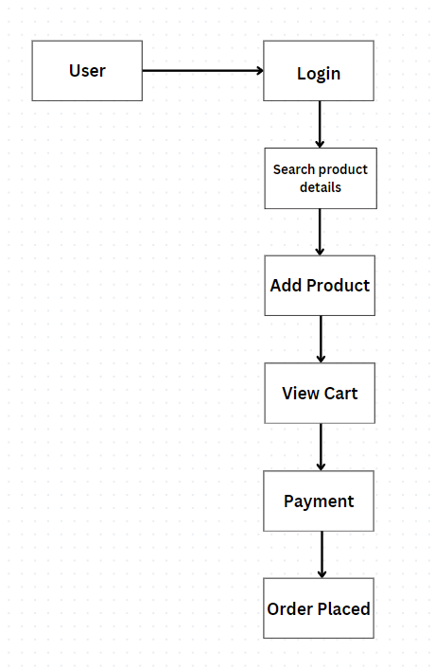

**Fig. 2 Flow diagram of User**

Now we have flow diagram of admin where admin request to login and after getting the response the admin can add the product, Edit Product, Delete Product, Produce the list of products, see the order list and check payment status of users. Given below is the flow diagram for admin (Fig. 3)

**Fig. 3 Flow diagram of Admin**

***3.4 Working Principle***

The e-commerce website permits users to investigate, select, and buy things online, acting as a virtual marketplace. The next steps are guided by the website's easy-to-use interface:

* **Product Browsing**: Customers may look through a enormous selection of items that are arranged according to a number of factors, including brand, price, kind, and characteristics.
* **Product Selection**: Following the identification of a desired product, customers have access to comprehensive product details, such as specs, photos, descriptions, and user reviews.
* **Cart Addition**: Users can evaluate and change their selections after adding selected goods to the shopping cart.
* **Checkout Process**: Users must select a desired payment option, see the order summary, and supply shipping and billing information in order to complete the transaction.
* **Transaction:** Secure payment gateways are unified to facilitate secure and efficient transactions.
* **Order Approval:** Upon successful transaction, the order is confirmed, and an order confirmation email is sent to the user.

**CHAPTER 4: THEORETICAL ANALYSIS**

***4.1 Introduction to Tools used in Project***

***4.1.1 Introduction of Html***

Hyper-Text Mark-up Language (HTML) is a simple mark-up system used to create hypertext documents that are portable from one platform to another. HTML documents are SGML documents with generic semantics that are appropriate for representing information from a wide range of applications. HTML mark-up can represent hypertext news, mail, documentation, and hypermedia; menus of options; database query results; simple structured documents with in-lined graphics; and hypertext views of existing bodies of information.

**Advantages of Html**

1 It is widely used.

2 Every browser supports HTML language.

3 Easy to learn and use.

4 It is by default in every windows so we don’t need to purchase extra software.

***4.1.2 Introduction of CSS***

Cascading Style Sheets, fondly referred to as CSS, is a simply designed language intended to simplify the process of making web pages presentable. CSS allows you to apply styles to web pages. More importantly, CSS enables you to do this independent of the HTML that makes up each web page.

**Advantages of CSS**

1. Greater consistency in design.

2. Ease of presenting different styles to different viewers.

**Friendly Environment**

Creating a form, adding controls to form and writing code behind the form are all managed within a friendly Environment.

**For Example:**

<!DOCTYPE html>

<html>

<head>

<title>Simple HTML and CSS Example</title>

<style>

body {

font-family: Arial, sans-serif;

text-align: center;

}

h1 {

color: blue;

}

p {

color: green;

}

</style>

</head>

<body>

<h1>Hello, World!</h1>

<p>This is a simple paragraph.</p>

</body>

</html>

***4.1.3 About PHP:***

PHP: Hypertext Pre-processor is a widely used, general-purpose scripting language that was originally designed for web development to produce dynamic web pages. For this purpose, PHP code is embedded into the HTML source code and can be interpreted but a web server with PHP processor module, which helps to generate web page document. PHP is a general-purpose scripting language that is especially suited to server-side web development where PHP generally runs on a web server. It can also be used for command line scripting and client- side GUI application. Many operating system and platforms, can be used with many relational database management systems. It is also free of charge.

**For Example:**

<?php

// A simple PHP script to print "Hello, World!"

echo "Hello, World!";

?>

***4.1.4 Working with PHP:***

When a client requests web page containing PHP code from the server, then the requested PHP pages are passed under PHP environment and interaction with database is made if required. After server side processing, the resulting HTML pages are passed to client and displayed on the browser. In this way the working of PHP is complete.(Fig.

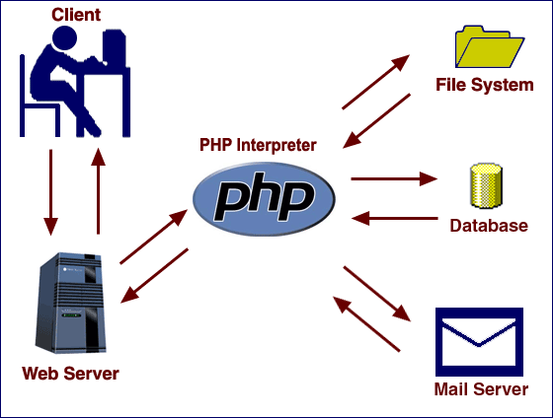

**Fig. 4 Working of PHP**

***4.1.5 Connecting PHP Application with MySQL Database***

* **Connect to the database**

$conn = mysqli_connect("localhost", "username", "password", "database_name");

* **Check connection**

if (!$conn) {

die("Connection failed: " . mysqli_connect_error());

}

* **Select data from the database**

$sql = "SELECT * FROM your_table_name"; $result = mysqli_query($conn, $sql);

* **Process the results**

if (mysqli_num_rows($result) > 0) {

while($row = mysqli_fetch_assoc($result)) {

// Access data from each row

echo "ID: " . $row["id"] . "<br>";

echo "Name: " . $row["name"] . "<br>";

// ... other fields

}

}

else { echo "0 results"; }

mysqli_close($conn);

***4.1.6 Introduction to MySQL:***

MySQL is a Relational Database Management System (RDBMS) that runs as a server providing multi-user access to a number of databases. MySQL is pronounced (“My S-Q-L”)

MySQL development project has made its source available under the terms of General Public License. MySQL is owned and sponsored by a single for profit firm, the Swedish company MySQL AB, now owned by Sun Microsystem, a subsidiary of Oracle Corporation.

MySQL works on many different system platforms including AIX, BSD i, FreeBSD, HP-UX, i5/OS, Linux, Mac OS X, Net BSD, Novell NetWare, Open BSD, Open Solaris, e com Station , OS/2 Wrap, QNX, IRIX, Solaris, Symbian, SunOS, SCO Open Server, SCO Unix Ware, Sanos, Tru64 and Microsoft Windows. A port of MySQL to Open VMS also exits. All major programming languages with language-specific APIs include Libraries for accessing MySQL database. In addition, an ODBC interface called MYODBC allows additional programming languages that supports the ODBC interface to communicate with a MySQL database, such as ASP or ColdFusion. MySQL server and official libraries are mostly implemented in ANSI C/ ANCI C++.

***4.1.8 Introduction to APACHE SERVER***

In this project apache server is user to parse and execute PHP pages, before deploying websites on the server, the website should be tested at the developer’s side to get a feel of how the website will work on actual server. Therefore apache server is like a local server on the developer side, apache server should be informed about the environment on which it should work. In our project apache server is configured to work with PHP, in this way all the PHP pages are parsed and executed by the server. (Fig. 5)

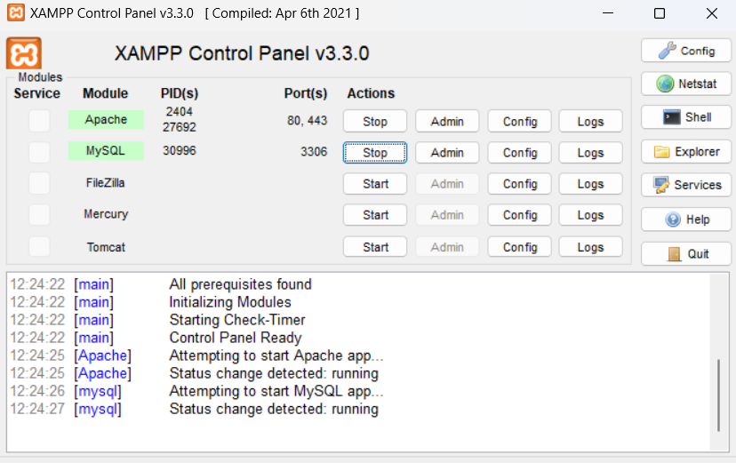

**Fig. 5 Apache Monitor(Xampp Control Panel)**

**CHAPTER 5: Methodology**

***5.1 Methodology***

Using the MySQL data will be stored from admin and by User.

Using the Search Option the user can search the goods.

For front end development – HTML, CSS, JS.

Back End – PHP , MySQL & APACHE SERVER.

Modules-

1. ADMIN

* Order Management
* Today Order
* Pending Order
* Delivered Order
* User Management
* Insert Product
* Manage Product
* Manage Payment

2. USER

* View Items
* View Recommendation
* View Related Products
* View Additional product
* Add to Cart
* Wish-list
* Payment Gateway and Order Confirmation

**CHAPTER 6: RESULTS AND CONCLUSION**

***6.1 Results***

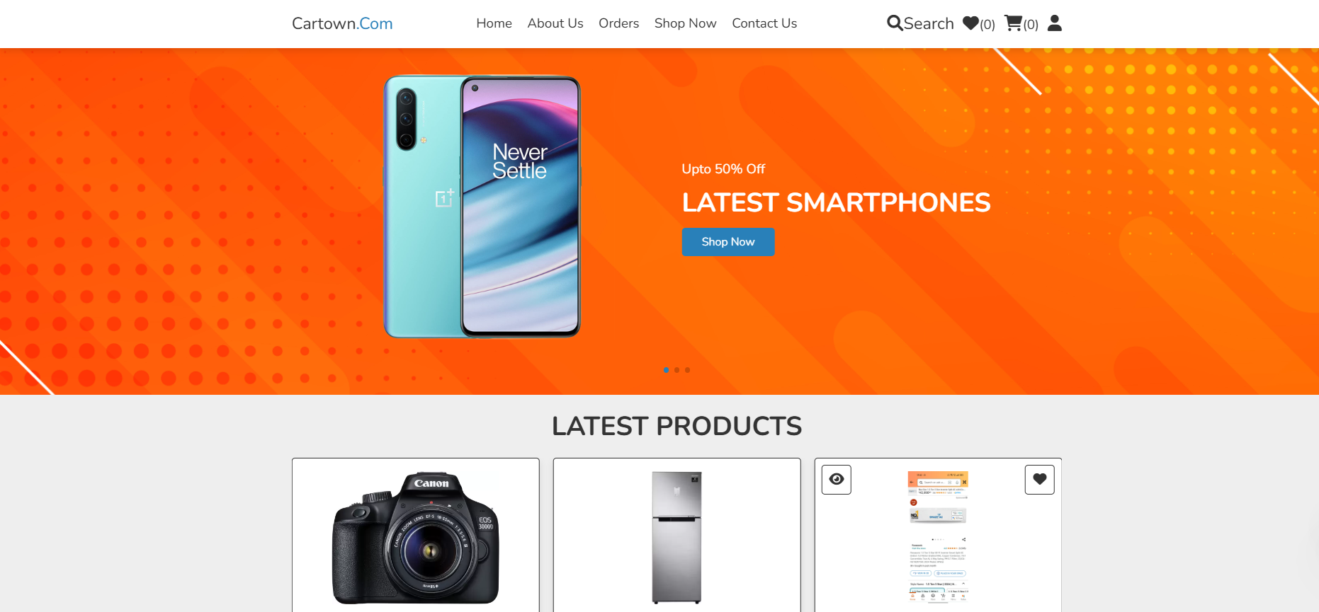

**Fig. 6(a) Home Page**

**Fig. 6(b) Register and Login Page**

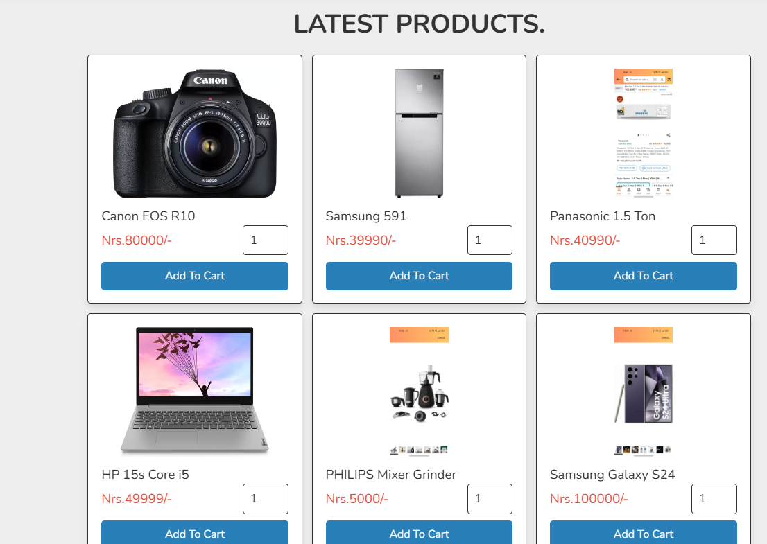

**Fig. 6(c) Product Page**

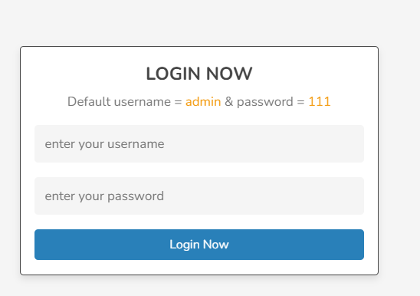

**Fig. 6(d) Admin Login Page**

**Fig. 6(e) Admin Dashboard**

**Fig. 6(f) Insert Product**

***6.2 Conclusion***

This project effectively addressed the rising demand for online shopping by creating a strong e-commerce website. The platform provides effective order processing, safe payment methods, and an intuitive user experience. The website attempts to improve consumer happiness and stimulate corporate growth by using cutting-edge technologies.

To meet the changing demands of online buyers, future improvements may incorporate social networking capabilities, optimize mobile responsiveness, and apply tailored product suggestions.